INFO 7374 Spring 2019

Assignment 1

Group 6

Byron Kiriibwa

With the following model set up

model = Sequential()

model.add(Dense(512, activation='relu', input_shape=(3072,)))

model.add(Dropout(0.2))

model.add(Dense(512, activation='relu'))

model.add(Dropout(0.2))

model.add(Dense(num_classes, activation='softmax'))

And the following configurations [batch_size = 128, num_classes = 10, epochs = 20]

I got the following results;

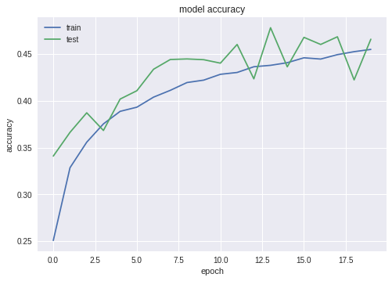

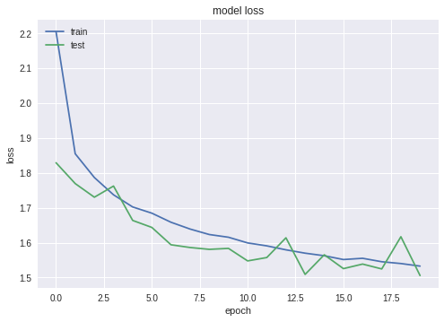

The results show that the model loss started leveling off at about 12 epochs and the model accuracy didn't change much after the first 12 epochs.

When other factors were held constant and the batch size changed to 256, the pictures below show how the model accuracy and loss reacted





There was no significant change in accuracy or validation accuracy after changing the bach size

When the batch size was changed to 512 and the number of epochs increased to 100, the model starts over fitting after about 15 epochs

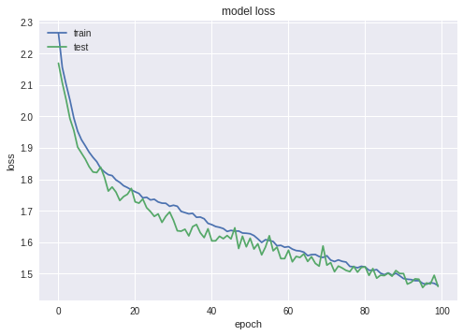

## Comment on how good your model is ? Does it overfit/underfit data ? What could you do to improve the model?

Output of my model:

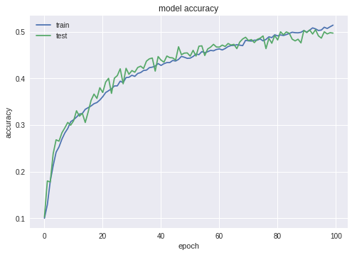

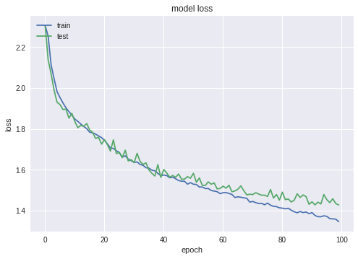

From the graphs we can see, the model is a little overfitting around after 70 epochs. The accuracy is about 50%. I tried to add more layers to improve the accuracy, and used larger drop rate to prevent overfitting but the results didn’t get better. In order to get more accurate result, we may need more data or choosing other model with higher efficiency.